**Multi-structural fibril-reinforced poro-hyperelastic (MS-FRPHE) finite element model to investigate the zone-specific mechanics of cartilage and its constituents**

Saiful Islam1, Malek Adouni2, and Tanvir R. Faisal1,*

1Dept. of Mechanical Engineering, University of Louisiana at Lafayette, USA

2Biomedical and Instrumentation Engineering, Abdullah Al Salem University, Khalidiya, Kuwait.

Saiful Islam; ORCID ID: 0009-0000-1686-4522; Email: [md-saiful.islam1@louisiana.edu](mailto:md-saiful.islam1@louisiana.edu)

Malek Adouni; ORCID ID: 0000-0003-4240-2254; Email: [malek.adouni@gmail.com](mailto:malek.adouni@gmail.com)

*Corresponding author:

Tanvir R. Faisal

ORCID ID: 0000-0003-3265-7579

Department of Mechanical Engineering

University of Louisiana at Lafayette

LA, 70503, USA

Email: [tanvir.faisal@louisiana.edu](mailto:tanvir.faisal@louisiana.edu)

Tel: +1 (337) 482-5360

**Abstract**

While existing cartilage models have made substantial progress in characterizing tissue-level mechanics, the integration of cellular microenvironments with the explicit dynamics of the collagen fibrillar network remains an area of ongoing investigation. In this study, a high-fidelity multi-structural fibril-reinforced poro-hyperelastic (MS-FRPHE) experimentally validated finite element model integrating extracellular matrix (ECM), pericellular matrix (PCM), chondrocytes, and type II collagen fibrils were proposed to assess the mechanics of cartilage and *in situ* chondrocytes in greater details. Depth-dependent (zone-wise) variations in type II collagen fibril and cell density as well as its morphology were incorporated in the proposed axisymmetric model. The mechanistic behavior of the cartilage and its constituents were simulated for 20% compressive strain—a typical physiological strain. Our proposed cartilaginous model was validated against *in vitro* stress-relaxation test with similar loading (strain rate of 100% s⁻¹) and boundary conditions, yielding an excellent agreement between computational and experimental peak force, 3.7 N for the both, and the Young’s modulus of 3.32 MPa (simulated), and 3.36 ±1.2 MPa (experimental). The model revealed distinct zone-specific mechanical behavior, with the middle zone exhibiting peak ECM strain (≈0.74), exceeding superficial zone strain by 12% and deep zone strain by 37%. PCM strains consistently exceeded ECM values by 63%, 42%, and 20% in superficial, middle, and deep zones, respectively, demonstrating its role in mechanotransduction amplification. Zone-specific cellular responses showed differential deformation patterns, with chondrocyte size reductions of 56%, 49%, and 21% in superficial, middle, and deep zones, respectively. The fibrillar network stress distribution of the proposed model was also consistent with the orientation-dependent behavior, with maximum stress of 3.5 MPa in superficial fibrils aligned parallel to the surface, and negligible stress in vertically oriented deep zone fibrils. These detailed insights into cartilage's depth-dependent mechanobiology establish a robust framework for understanding tissue pathophysiology and designing stratified biomaterials that replicate zone-specific mechanical properties, potentially advancing treatments for cartilage degeneration and osteoarthritis.

**Keywords:** Chondrocyte mechanobiology, collagen fibril mechanics, zone-specific mechanics, fibril-reinforced poro-hyperelastic model, finite element analysis, articular cartilage.

**1. Introduction**

Articular cartilage is an avascular connective tissue that absorbs shock and reduces stress, facilitating smooth low-friction movement in diarthrodial joints (Sophia Fox et al. 2009). This multiphasic tissue comprises 70-80% water and chondrocyte embedded within an extracellular matrix (ECM), which primarily consists of type II collagen fibrils, proteoglycans (PGs) and other glycoproteins (Athanasiou et al. 2009; Mow et al. 2005; Responte et al. 2007). Articular cartilage also exhibits depth-dependent heterogeneity (Schinagl et al. 1997; Wang et al. 2001) that substantially influences its mechanical integrity (Chahine et al. 2004; Wang et al. 2001). While PGs are responsible for compressive stiffness at equilibrium, the collagen fibrillar network enhances the tissue’s mechanical properties for load bearing, joint lubrication, and wear endurance (Dubey and Deng 2018). This collagen network plays a crucial role in the tissue's tension-compression nonlinearity (Chahine et al. 2004), enabling greater interstitial fluid pressurization, which enhances load support and lubrication (Ateshian 2009).

Experimental measurement of the mechanical properties of cartilage constituents is challenging but can be accomplished computationally through multiscale finite element (FE) modeling. Among various approaches, fibril-reinforced poroelastic (FRPE) material modeling demonstrated its ability to capture complex dynamic, transient, and equilibrium mechanical behavior of articular cartilage (Fortin et al. 2000; Julkunen et al. 2013; Li et al. 2009). Various fibril-reinforced models have evolved, including transversely isotropic (Cohen et al. 1998; Donzelli et al. 1999; Korhonen et al. 2002) or conewise linear elastic (Soltz and Ateshian 2000a), vector-based fibril reinforcement (Pierce et al. 2009; Seifzadeh et al. 2011; Wilson et al. 2006; Wilson et al. 2005; Wilson et al. 2004), and fibril reinforcement incorporating membrane and spring elements (Korhonen et al. 2003; Li et al. 1999; Shirazi and Shirazi-Adl 2005). Combined spring or membrane elements with a poroelastic matrix effectively capture cartilage’s compression-tension nonlinearity (Li et al. 1999; Shirazi and Shirazi-Adl 2005). These models account for key structural parameters including fibril orientation (Ateshian et al. 2009; Olsen et al. 2004), dispersion patterns (Gasser et al. 2006; Holzapfel and Gasser 2001), and density distributions (Quinn and Morel 2007) in both 2D and 3D analyses (Pierce et al. 2010). Although these approaches successfully captured the bulk effects of fibril heterogeneity, they were unable to represent fibril kinematics and kinetics explicitly due to the absence of discrete geometric representations of individual collagen fibrils. This limitation has constrained our ability to fully understand the microscale mechanical behavior of the collagen network and its contribution to cartilage's overall mechanical response.

While existing FRPE models effectively incorporate ECM permeability, fluid flow, and swelling characteristics along with fibril heterogeneity, embedded chondrocyte and its cellular microenvironment are often ignored. Prior attempts with single-cell (Federico et al. 2005; Kim et al. 2008) and multicell (Halloran et al. 2018; Tanska et al. 2020) models were simplified by considering uniform cell shapes even though chondrocytes exhibit zone-wise variations (Halloran et al. 2018), isotropic material properties (Istiak et al. 2025a; Klets et al. 2016), the misrepresentation of cellular volume fraction in the ECM (Tanska et al. 2020), and ignoring both cellular interactions and collagen fibril deformation behavior (Halloran et al. 2018). The *in situ* chondrocyte mechanobiology is pivotal for measuring the physical and physiological health of cells in response to extracellular stimuli, thereby elucidating cell viability. The constituent-specific mechanical properties and their interactions within the FRPE framework thus remain incompletely characterized, and these limitations significantly impact on our understanding of cartilage mechanobiology. Therefore, the goal of this work is to develop a more comprehensive cartilage model including *in situ* chondrocyte and its cellular microenvironment, utilizing the FRPE framework.

The primary objective of this study was to construct a geometrically, structurally, and morphologically representative physics-based validated multiscale FE model. In this work, a multi-structural fibril-reinforced poro-hyperelastic (MS-FRPHE) finite element model is developed comprising ECM, pericellular matrix (PCM), chondrocytes, and type II collagen fibrils along with their zonal variations. The axisymmetric FE model was simulated under physiological load via unconfined compression and validated against *in vitro* tissue level bulk properties. The second objective was to assess the mechanics of collagen fibril, and ECM that directly influence the response of the tissue to mechanical load. Finally, the mechanobiology of *in situ* chondrocyte and its cellular microenvironment was investigated to understand how cells respond to mechanical forces.

**2. Materials and methods**

**2.1.** **Axisymmetric finite element model**

An axisymmetric FE model was constructed integrating depth-dependent variations in chondrocyte, PCM, and major macromolecules of cartilage ECM, including type II collagen fibrils, PG as well as glycosaminoglycans (GAGs) contents. The FE construct comprises three spatially distinct zones: the superficial zone (SZ), middle (transitional) zone (MZ) and deep zone (DZ), which constitute 10%, 20%, and 70% of the cartilage thickness, respectively (EB 1992; Jadin et al. 2005). The axisymmetric model represented cylindrical cartilage explants used in experiments with dimensions of radius,and thickness (height),. The depth-dependent spatial and morphological variations at different zones were analogously considered in the FE construct (Table 1).

**Table 1** Parametric values of spatial and morphological variations considered in constructing the axisymmetric FE model comprising chondrocyte, PCM, and ECM with type II collagen fibril heterogeneously oriented in different zones. Chondrocyte, PCM, and ECM was discretized using 4-node axisymmetric porous element (CAX4P) and 2-node connector element (CONN2D2) was used to represent collagen fibril.

|  |  |  |  |  |  |
| --- | --- | --- | --- | --- | --- |
| Zone | Chondrocyte | PCM | ECM | Collagen fibril | Cartilage element  (single quadrant) |
| SZ with no cell |  |  |  |  |  |
| SZ with cell |  |  |  |  |  |
| MZ with no cell |  |  |  |  |  |
| MZ with cell |  |  |  |  |  |
| DZ with no cell |  |  |  |  |  |
| DZ with cell |  |  |  |  |  |

In this construct, the SZ was modeled with flattened chondrocytes oriented parallel to the surface, the MZ was modeled with round-shaped chondrocytes, and the DZ comprised columnar chondrocytes (Youn et al. 2006). The zonal variations in cell distribution were incorporated into the construct, with cell density ratio of 3:2:1 in the SZ, MZ, and DZ, respectively (Fig. 1) (Hunziker et al. 2002; Ren et al. 2016a). Furthermore, the orientation of type II collagen fibrils was preserved, with fibrils arranged parallel to the surface in the SZ and perpendicular to the surface in the DZ. The fibrils in the MZ were modeled horizontally, vertically, and  to simulate the random fibril distributions observed in this zone. The superficial, transitional, and deep zones were modeled with fibril volume fractions of 15%, 18%, and 21%, respectively (Adouni et al. 2012; Faisal et al. 2019; Faisal et al. 2023; Shirazi and Shirazi‐Adl 2008; Wilson et al. 2004). Since collagen fibrils are not present in chondrocytes (Nahian and Sapra 2020), the fibrils were modeled around the chondron without overlap (Table 1 and Fig. 1).

**Fig. 1.** **(a)** Zone-wise representative volume elements (RVE), the building block of the axisymmetric FE model with the maximum cell density in the SZ, and lowest at the DZ (3:2:1); **(b)** Axisymmetric (whole) model of cartilage explant with three different zones and loading and boundary conditions.

**2.2**. **Fibril-reinforced poro-hyperelastic material model**

A biphasic constitutive framework (material model) consisting of solid and fluid phases was implemented in this physics-based FE model. The solid phase comprised a porous hyperelastic non-fibrillar matrix (representing proteoglycans) reinforced with a non-linear elastic collagen fibril network (Julkunen et al. 2010; Suh and Spilker 1994). The total stress tensor,  consisted of the stress induced by both fibrillar network and non-fibrillar matrices in combination with fluid (pore) pressure (Julkunen et al. 2013; Pierce 2022).

 (1)

where  is the stress tensor of the non-fibrillar matrix,  is the stress tensor of a fibril , is the fluid pressure, and  is the unit tensor.

**2.2.1. Non-fibrillar matrix**

The non-fibrillar matrix (PG) was modeled with a neo-Hookean hyperelastic material model, and the corresponding non-fibrillar stress tensor,  , is,

 (2)

where  and  are the bulk and shear moduli of the non-fibrillar matrix, respectively,  is the deformation gradient tensor,  is the determinant of the  , and  is the unit tensor (Wilson et al. 2005). The bulk and shear moduli of the non-fibrillar matrix can be further expressed as a function of Young’s modulus () and Poisson’s ratio () as follows,

 (3)

 (4)

In this model, the GAG component was incorporated to provide a more precise representation of the biomechanical behavior of articular cartilage compared to the ideal Donnan model (Buschmann and Grodzinsky 1995; Stender et al. 2013). The GAG Cauchy stress is expressed as,

 (5)

where  and are GAG material constants.

**2.2.2. Fluid phase**

Darcy’s law (Holmes and Mow 1990) was employed to describe intra-tissue fluid flow within the porous matrix as follows:

 (6)

where  is the rate of fluid flow,  is the (hydraulic) permeability of the materials, and  is the (fluid) pressure gradient. Deformation within the porous material leads to alterations in the void ratio, which represents the ratio of fluid volume to solid volume, thereby causing changes in permeability (Van der Voet 1997). The strain-dependent permeability, is expressed as

 (7)

where  and  represent the current and initial permeability, and  represent the current and initial void ratio, respectively, is a positive constant describing the void-ratio (deformation or strain) dependency of permeability (Grillo et al. 2017; Van der Voet 1997; Wilson et al. 2004).

**2.2.3. Collagen fibrils**

To investigate fibrillar network mechanics, Abaqus connector elements were implemented in this FE construct, with collagen fibrils being assumed to be homogenously distributed within the non-fibrillar matrix. The connector element was selected for its capacity to accommodate large deformations typically experienced by the fibrils. The connector properties of each fibril were defined by force-displacement relationships derived from the nonlinear stress-strain mechanical property of individual collagen fibers, as reported in prior studies (Haut and Little 1972; Morgan 1960; Shirazi and Shirazi-Adl 2005). The force was calculated employing zone-wise fibril volume fractions, the number of fibrils, and the surface area. For an individual fibril, the force was calculated as follows: 

 (8)

where is the zone-wise fibril volume fraction (mentioned in Section 2.1),  is the fibril stress corresponding to the strain obtained from (Haut and Little 1972; Morgan 1960; Shirazi and Shirazi-Adl 2005), andis the zone-wise surface area, and represents the number of fibrils in each zone. Accordingly, the values were  and  for the superficial zone,  and  for the middle zone, and  and  for the deep zone. The relative displacement (change in fibril length) of the individual fibril was calculated as follows,

 (9)

where is a change in fibril length, is the original length of an individual fibril, and is the strain values obtained from the literature (Haut and Little 1972; Morgan 1960; Shirazi and Shirazi-Adl 2005) as well. A translational basic AXIAL connection type was implemented in this study, connecting node pairs where orientation acting along their connecting line. The AXIAL connection allows all components of relative motion to remain unconstrained.

**2.2.4. Material properties**

For the non-fibrillar matrix, a user defined material (UMAT) subroutine was written to assign the material parameters for each element set including ECM, PCM, and Cell. Based on the hyperelastic material model (Eq. 2), Young’s modulus, , and Poisson’s ratio, were defined in UMAT for each set. A permeability look up table was created using Eq. 4 with corresponding , ,and  values for ECM, PCM, and cell (Table 2), and the values were incorporated in the material model eventually. The initial void ratio  was fixed to 4.0, and the value of  was considered 7.1. A cyclic optimization procedure (Fig 2.) was implemented to calibrate both hyperelastic and poroelastic properties of the non-fibrillar matrix. Initial ranges of these parameters were obtained from prior studies (Table 2). At each iteration, the values of , , and were updated via MATLAB (The MathWorks, Inc., Natick, MA, USA) scripting and FE simulation was conducted unless the material parameters of each element set were optimized. A Levenberg-Marquardt algorithm was used to optimize the material parameters. The objective function of the optimization routine minimized the normalized mean squared error between the simulated and experimental data, which was modified with a weighting factor resulting from peak data points as follows:

 (10)

where and are simulated and experimental force values, and are peak force values obtained from the simulation and experiment, respectively; and and  correspond to the total number of data points and number of peak data points (m=1), respectively.

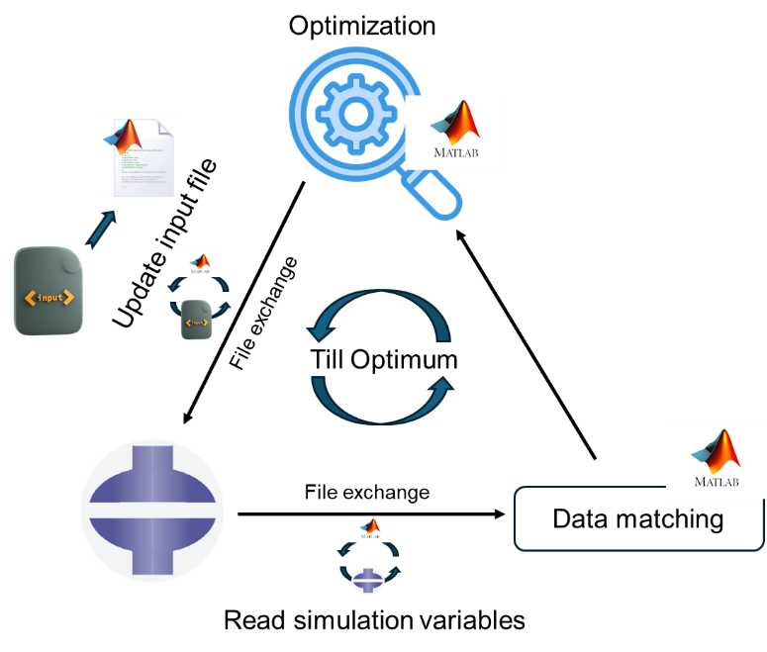

**Fig. 2**. Cyclic (MATLAB-ABAQUS) workflow for material parameter optimization

**Table 2.** Typical range of material parameters for ECM, PCM, and Cell (Darling et al. 2010; Tanska et al. 2020)

|  |  |  |  |
| --- | --- | --- | --- |
| Parameter | ECM | PCM | Cell |
|  | (0.1-3.0) | (0.014-0.31) | (0.001-0.023) |
|  | (0.04-0.45) | (0.04-0.48) | (0.01-0.48) |
|  | (0.6-6.0) | 0.1xECM | 100xECM |

**2.3. FE model with boundary and loading conditions**

The 2D axisymmetric FE model was meshed with 4-node axisymmetric porous element (CAX4P). The mesh size of the axisymmetric model underwent sensitivity analysis until a 5% difference in the reaction force was achieved. Unconfined compression was simulated using a flat indenter, modeled as a rigid body in contact with the cartilage’s top surface. Displacement boundary conditions (BCs) were applied following the experimental set-up. The bottom nodes were constrained in the y-direction, and the axisymmetric axis nodes were fixed along x-direction (Fig. 1). Zero pore pressure was prescribed at the outer surface of the cartilage, allowing fluid outflow through this boundary (surface).

**2.4. Mechanical testing**

Unconfined compression stress-relaxation experiments were conducted to validate the FEA. The mechanical testing protocol incorporated a two-phase loading regime: an initial compression phase followed by a relaxation phase. During compression, the specimen was subjected to a prescribed displacement of 0.24 mm, corresponding to 20% compressive strain, applied at a constant strain rate of 100% s⁻¹. Following compression, the deformation was maintained at the 20% strain level for 400 s to allow sufficient time for stress-relaxation to attain equilibrium condition. This loading enabled the characterization of both the instantaneous and time-dependent mechanical responses of the cartilage tissue under physiologically relevant loading conditions.

**3. Results**

**3.1. Experimental validation**

The optimization of material parameters using the Levenberg-Marquardt algorithm yielded excellent agreement between experimental and computational predictions of stress relaxation behavior. The force-time response demonstrated characteristic biphasic mechanics, characterized by an initial peak reaction force of 3.7 N followed by time-dependent stress relaxation to an equilibrium value of approximately 0.2 N over 400 seconds. The optimized MS-FRPHE model successfully captured both the instantaneous and time-dependent mechanical response through three distinct phases: initial peak loading—reaching 3.7 N at t=0.2s, rapid force decay—occurring from 0.2-50s, and gradual equilibration to steady state. The weighted objective function effectively minimized the normalized mean squared error , while maintaining accuracy at the critical peak force value. The closed correlation between experimental measurements and numerical predictions confirms the validity of the MS-FRPHE model. These optimized parameters were then utilized to analyze the depth-dependent mechanical behavior across the tissue’s three distinct zones (SZ, MZ, and DZ), establishing a robust framework for investigating zone-specific mechanical responses and cellular mechanobiology in subsequent analyses.

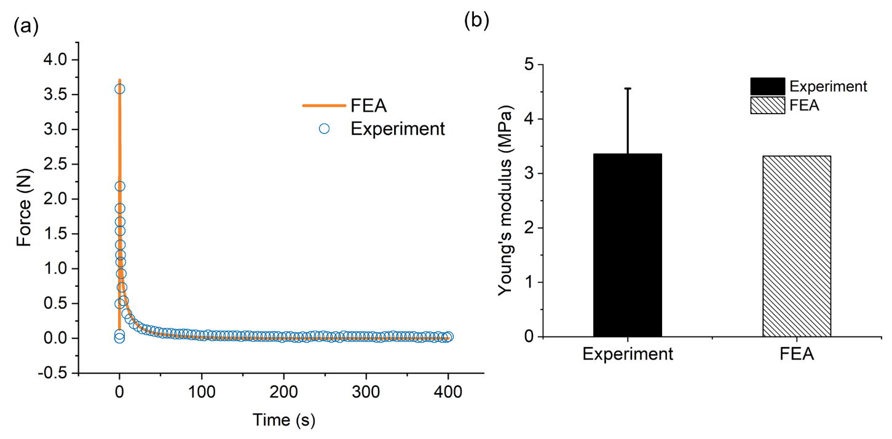

**Fig. 3.** (a)Comparison of (a) experimental and optimized FEA force-time response in stress relaxation analysis, and (b) Young’s modulus between experiment and FE simulation

The developed MS-FRPHE finite element model was further validated through experimental comparison of compressive Young’s modulus. *In vitro* experiment was performed using bovine cartilage specimens of identical dimensions under similar loading and BC, following the established protocol from our previous studies (Istiak et al. 2025b; Mixon et al. 2022; Mixon et al. 2021). The developed FE model exhibits excellent agreement with experimental results (Fig. 3b), yielding Young's modulus of 3.32 MPa for FEA in comparison with experimental modulus of 3.36 ± 1.2 MPa. This close correlation validates the model's ability to accurately capture the tissue's bulk mechanical properties under physiological loading conditions.

**3.2. Interstitial tissue and cellular response**

Analysis of zone-specific strain distributions during unconfined compression revealed distinct mechanical responses across the cartilage depth in the ECM, PCM, and chondrocytes. Figure 4a illustrates the compressive logarithmic strain distribution in cartilage components, ECM demonstrated zone-specific strain variations, with a peak strain of approximately 0.74 at MZ. This value exceeded the SZ strain (≈ 0.66) by 12% and the DZ strain (≈ 0.54) by 37%. These zonal differences can be attributed to distinct structural features. The PCM exhibited elevated strain levels compared to ECM across all the zones. In the SZ, PCM strain reached approximately 1.08, representing a 63% increase over the local ECM value (≈ 0.66). MZ showed a similar pattern, with PCM strain (≈ 1.05) exceeding ECM strain (≈ 0.74) by approximately 42%. However, in DZ, PCM strain (≈ 0.65) demonstrated a 20% increase over ECM strain (≈ 0.54), reflecting a more uniform mechanical environment compared to the SZ and MZ. Chondrocyte deformation patterns revealed distinct zonal variations. SZ chondrocytes experienced the highest strain (≈ 1.21), surpassing the local PCM strain (≈ 1.08) by 12% and the ECM strain (≈ 0.66) by 83%. MZ chondrocytes followed a similar trend, with cellular strain (≈ 1.14) exceeding PCM strain (≈ 1.05) by approximately 7%. In contrast, chondrocytes in DZ maintained strain levels (≈ 0.69) comparable to the surrounding ECM (≈ 0.54) and PCM (≈ 0.65), reflecting the fact the PG in the DZ provides the mechanical environment not the vertical fibrils.

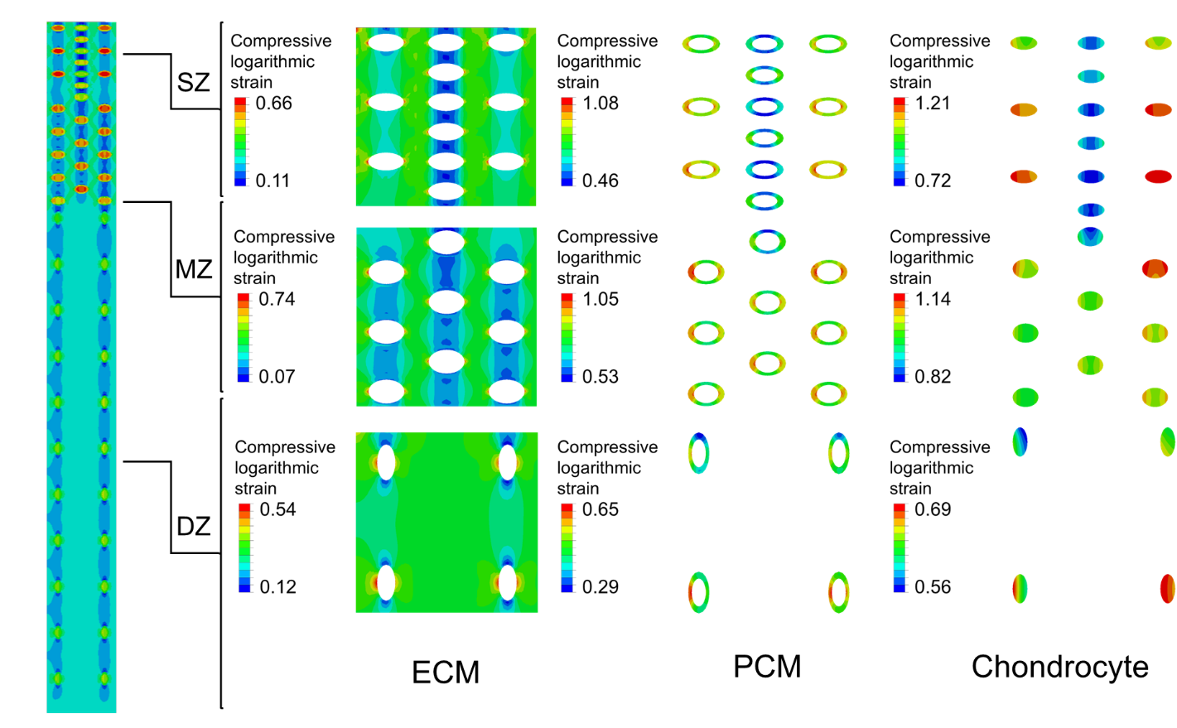

(a) Zone-wise contour plot of compressive logarithmic strain in ECM, PCM, and chondrocyte

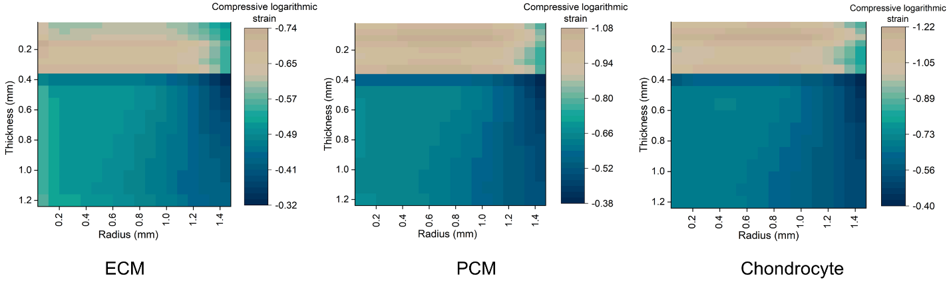

(b) Compressive logarithmic strain mapped against cartilage thickness and radius in ECM, PCM, and chondrocyte

**Fig. 4** Zone-wise contour plot of compressive logarithmic strain (a) and compressive logarithmic strain mapped against cartilage thickness and radius (b) in ECM, PCM, and chondrocyte. SZ: Superficial zone (0 – 0.12 mm), MZ: Middle zone (0.12 – 0.32 mm), and DZ: Deep zone (0.32 – 1.2 mm).

Figure 4b exhibits radial and axial distributions of compressive logarithmic strain across all three components. Peak ECM strain was observed near the center axis, where the load was applied, and decreased toward the periphery. However, PCM and chondrocytes in the mid-radial location were subjected to the highest compressive logarithmic strain. This strain gradient reflected the progressive release of fluid pressure and lateral expansion permitted by the unconfined boundary condition.

**3.3. Fibrillar response**

Figure 5 illustrates the stress distribution in the fibrillar network in FE model (Fig. 5a) and stress contours in fibrils across zones (Fig. 5b). The MS-FRPHE model demonstrates compression-tension nonlinearity with a maximum stress of ~3.5 MPa in collagen fibrils in SZ, 1.2 MPa in MZ with 65.7% reduction from SZ and negligible stress in DZ. The horizontal, vertical, and ±45° diagonal fibrils orientations in MZ provide effective resistance to compressive loads, while vertically aligned DZ fibrils show minimal to no stress response under compression.

**Fig. 5**. Overall (a) and zone-wise (b) stress distributions in type II collagen fibril network in cartilage tissue

**3.4. Cellular morphology**

The chondrocytes exhibit zone-specific distinct cellular deformation patterns. SZ chondrocytes experienced the maximum size reduction (56%), followed by middle zone cells (49%), while deep zone chondrocytes underwent modest changes (21%) (Fig. 6). The aspect ratio changes are particularly striking, with substantial increases in both superficial zone 3.6 (initial 2.0) and middle zone 2.4 (initial 1.33), contrasting with a decrease in the deep zone 1.07 (initial 2.0). These findings translate to normalized aspect ratios of 1.9 and 1.8 for SZ and MZ (Fig. 6), respectively, aligning with previous studies that documented ratios between 1.5 and 11 for varying initial configurations (Guo and Torzilli 2016). These quantitative findings provide crucial insights into zone-specific cellular mechanobiology and its potential implications for tissue homeostasis.

**Fig. 6.** Zone-wise comparison of (a) chondrocyte shapes before and after compression and (b) the normalized aspect ratio (deformed to undeformed shape) of chondrocyte.

**3.5. Poromechanical fluid response**

The poromechanical behavior of articular cartilage under unconfined compression was depicted through the spatial distributions of both pore pressure (Fig. 7a) and fluid velocity (Fig. 7b) within ECM, PCM, and chondrocytes. This comprehensive analysis elucidates the intricate relationships between fluid pressurization patterns and flow pathways across the tissue depth and its constituent components, providing essential insights that complement our understanding of solid-phase mechanical responses.

**3.5.1. Pore pressure distribution**

The spatial distribution of pore pressure across cartilage revealed distinct zonal and radial variations (Fig. 7a) that demonstrate the tissue’s biphasic response to compressive loading. SZ revealed highest pore pressure of ~0.34 MPa at its center, declining axially to 0.15–0.25 MPa in MZ and below 0.10 MPa in DZ. Radially, pressures decreased from the axis toward the periphery in both SZ (~0.34 to ~0.25 MPa) and MZ (highest near the center, lower at the edge), whereas the DZ remained uniformly low. Overall, the steep axial drop from surface to mid-depth was accompanied by a more moderate radial gradient, while the deep layer remained uniformly low.

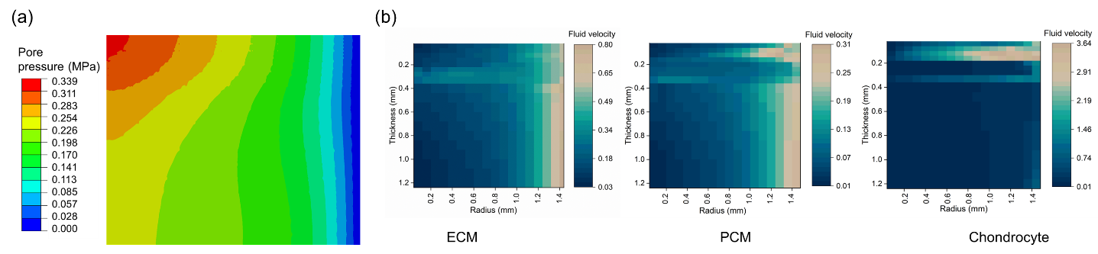

**Fig. 7.** (a) Pore pressure distribution in articular cartilage subjected to 20% of strain under unconfined compression. (b) Fluid velocity distributions across cartilage components. Thickness (0 – 0.12 mm): SZ, (0.12 – 0.32 mm): MZ, (0.32 – 1.2 mm): DZ.

**3.5.2. Fluid velocity distributions in ECM, PCM, and chondrocytes**

Analysis of fluid velocity fields (Fig. 7b) revealed complex spatial patterns that vary with depth, radial position, and tissue microstructure. The ECM exhibited the highest fluid velocity, reaching maximal values exceeding 0.80 mm/s near the bottom-lateral boundaries. Within SZ, ECM fluid velocities range from approximately 0.03 mm/s along the central axis to over 0.57 mm/s at the periphery. The PCM exhibited a similar spatial distribution pattern, though with velocities typically reduced by 30–60% compared to the ECM, reflecting its protective role in buffering chondrocytes from rapid pressure fluctuations. In MZ, ECM fluid velocities reached 0.32–0.37 mm/s, while PCM velocities remained more constrained (approximately 0.05–0.25 mm/s). Notably, chondrocytes occasionally exhibited fluid velocities comparable to or exceeding those in the surrounding PCM, particularly in regions of high cellular permeability. DZ demonstrated a distinct pattern where central ECM velocities fell below 0.02 mm/s, while lateral boundaries maintained peak velocities above 0.80 mm/s and localized areas within the chondrocyte region revealed similar increases in flow. This spatial heterogeneity in fluid velocities is strongly correlated with the depth-dependent variations in tissue permeability and microstructural organization.

**4. Discussion**

In this study, we investigated the depth-dependent poromechanical behavior of cartilage and its constituents and *in situ* chondrocyte mechanobiology via a high-fidelity, experimentally validated MS-FRPHE model under physiological loading conditions. In this study, we simulated typical physiological loading conditions experienced by articular cartilage during daily activities– a commonly adopted approach for assessing cartilage biomechanics (Deneweth et al. 2013; Elahi et al. 2021). The 20% strain and 100% s-1 strain rate effectively capture cartilage deformation, particularly the initial fluid pressurization crucial for load bearing. The developed multi-structural cartilage model investigating not only the tissue-level bulk properties but also zone-specific mechanics of type II collagen fibrillar network, ECM, PCM as well as *in situ* cellular response. Furthermore, the proposed model is built upon Abaqus connector element utilizing its unique ability to capture stress-strain behavior of fibrillar network, while the tissue undergoes compression. Since the axial connector elements can effectively capture the relative displacements between the two nodes (ABAQUS Online Documentation: Version 6.6-1), they are best suited for modeling the tensile behavior of collagen fibril, thereby mimicking the role of collagen fibrils in reinforcing the ECM and enhancing rapid fluid pressurization under physiological loading conditions. Another uniqueness of this model is the integration of chondrocyte and its cellular microenvironment with zone-specific geometry and density variations to reflect the native distribution across cartilage layers (Ren et al. 2016b). In addition, the PCM, surrounding the chondrocyte, was modeled with uniform thickness, ensuring a stable mechanical interface to facilitate load transfer to the cells. Simulating this high-fidelity cartilage model enhances our understanding of cartilage and *in situ* chondrocyte mechanobiology under physiological loading to greater detail.

The strain patterns across the ECM, PCM, and chondrocytes in different tissue zones showed distinct mechanical responses, reflecting the complex interplay between structural organization, matrix composition, fluid pressurization, and loading rate. Our results revealed that the SZ, under high strain-rate loading, can momentarily host the lower strain than MZ due to its dense, tangentially aligned collagen network and rapid poroelastic pressurization under constrained fluid flow (Li and Herzog 2004). Low hydraulic permeability in SZ traps interstitial fluid during rapid loading, elevating pore pressure and stiffening the matrix, thereby limiting bulk deformation (Setton et al. 1993). This protective mechanism is consistent with the SZ primary function of resisting shear and tensile stresses at the articular surface (Karpiński et al. 2025). In contrast, ECM’s transitional architecture in MZ creates a mechanical vulnerability. The abrupt change in collagen fibril orientation from tangential to random, combined with intermediate proteoglycan content, creates a region of mechanical discontinuity that concentrates strain during compression. This structural transition zone lacks both the efficient tensile reinforcement of SZ and the high compressive stiffness of DZ, resulting in elevated strain under similar loading conditions. The MZ isotropic fibril arrangement provides less structural resistance to compressive loading, allowing greater instantaneous compaction when fluid flow is constrained (Quiroga et al. 2017; Ravanfar and Yao 2019). ECM experienced lower compressive strain with zone-wise variations compared with PCM (Fig. 4). PCM strains consistently exceeded ECM values emphasizing that local mechanotransduction hotspots form where fluid‐structure interactions were most intense, offering both buffering and amplified mechanical signals. This significant difference demonstrates the PCM's enhanced compliance and its capacity to accommodate deformation while protecting chondrocytes. PCM’s composition and stiffness markedly influence cell-level strains as observed in prior atomic force microscopy (AFM) and micropipette aspiration experiments (McLeod et al. 2013; Wilusz et al. 2014). From a mechanobiological perspective, the SZ chondrocytes are more sensitive to shape changes and thus potentially at higher risk for injury when subjected to rapid or instantaneous loading (Argote et al. 2019; Bartell et al. 2015). These zone-specific deformation patterns suggest differential mechanotransduction responses, potentially influencing local metabolic activities, promoting the synthesis of collagen and proteoglycans (Kroupa et al. 2023; Quinn et al. 1998; Wong et al. 1997). Furthermore, a relatively uniform chondrocyte deformation in deeper zones corresponds with experimentally observed columnar cell shapes and lower metabolic turnover, suggesting that these cells respond to more modest mechanical cues essential for steady-state cartilage homeostasis (Boos et al. 2022; Stok et al. 2025; van der Kraan et al. 2010). Considering these findings, subtle changes in cell geometry or PCM properties, whether from aging, enzymatic degradation or traumatic injury could increase chondrocyte deformation beyond a safe threshold, potentially contributing to matrix breakdown and progressive cartilage damage to OA. The MS-FRPHE framework demonstrates significant potential for biomaterial design to preserve or restore cartilage health by creating a more favorable mechanical environment for chondrocytes, thereby reducing abnormal strain that can trigger degenerative processes and lead to cartilage breakdown.

The fibrillar network stress distributions conform with their orientation such that fibrils parallel to the surface in the SZ experience the maximum stress, whereas the fibrils oriented vertically in DZ withstand no to minimal stress. Our discrete connector element approach enabled explicit representation of individual collagen fibrils, allowing direct computation of fibrillar mechanics under physiological loading, a methodological advancement over previous homogenized fibril distribution models (Moore et al. 2023; Tan et al. 2023). This methodological advancement allowed us to capture the compression-tension nonlinearity inherent to cartilage mechanics, where superficial zone fibrils resist tensile stresses generated during compression while deep zone fibrils remain mechanically disengaged due to their perpendicular orientation to the loading direction. The density and orientation-wise mechanical behavior of collagen fibrils are crucial (Meng et al. 2017; Shirazi and Shirazi-Adl 2008) for developing new biomaterials with natural mechanical properties across the cartilage depth. The collagen network modulates both the solid-phase stiffness and the fluid dynamics within cartilage, ensuring efficient load distribution and maintaining tissue integrity (Korhonen et al. 2006). Any alteration in fibril alignment or density, whether due to degeneration, injury, or genetic factors could disrupt the integrated load-sharing mechanism, leading to compromised cartilage performance.

The proposed MS-FRPHE model also demonstrates depth-dependent variations in pore pressure and fluid velocity under rapid unconfined compression. The SZ develops peak pore pressure due to low permeability and restricted fluid flow, thereby enhancing hydrostatic support and increasing effective stiffness (Elder and Athanasiou 2009; Pattappa et al. 2019; Soltz and Ateshian 2000b). This localized pressure buildup plays a crucial role in the tissue's load-bearing capacity. MZ displays intermediate pore pressure distribution, reflecting its heterogeneous fibril orientation that transiently impedes fluid flow. DZ exhibits lower pore pressure as the vertical collagen fibrils facilitate efficient fluid flow toward the subchondral bone. This systematic decrease in pore pressure from superficial to deep zones illustrates cartilage's inherent mechanism for load absorption and transmission while protecting deeper structural components including chondrocytes from excessive compressive forces. Furthermore, ECM experiences the highest fluid velocities near the lateral boundaries, whereas SZ shows a steep radial gradient at the periphery. This behavior reflects rapid interstitial fluid exchange due to high local pressurization in SZ, indicating the dynamic fluid exchange under high interstitial fluid pressure. In contrast, the PCM consistently shows fluid velocities 20–35% lower than the ECM, indicating that its lower permeability moderate’s fluid flow and acts as a hydrodynamic buffer at the cell interface.As observed,the localized high fluid velocities near chondrocytes likely contribute to these shear forces. From the mechanistic viewpoint, these velocity gradients can induce shear stress on chondrocyte membranes by generating viscous drag proportional to the fluid’s viscosity (sharifi and Gharravi 2019; Spiteri et al. 2008; Zhu et al. 2010). Such shear stress influences cellular mechanotransduction, affecting nutrient transport and signal transduction pathways essential for cartilage maintenance (Yeh et al. 2013; Zhu et al. 2010).

The primary objective of this study was to develop a high-fidelity cartilage model, which is partially limited by focusing only type II collagen fibril, ignoring minor collagens such as type VI embedded in PCM and type IX that stabilize the collagen–proteoglycan network (Lanzer and Komenda 1990; Zelenski et al. 2015). Neglecting these collagens weakened local microscale reinforcement and thereby underestimating the mechanical integrity of cellular microenvironment. Furthermore, the developed model incorporated only zone-specific differences in collagen content and cell geometry, heterogeneity in proteoglycan concentration, permeability, and crosslink density remains the same throughout the model, potentially misrepresenting transitional behavior between the zones (Krakowski et al. 2024; Szarko and Xia 2012). However, the fidelity of the model will be further enhanced by integrating minor collagen types, and the model will be simulated for different loading conditions to yield more physiologically relevant predictions and design cartilage-like biomaterials.

In conclusion, this multiscale MS-FRPHE model provided insights into the depth-dependent mechanics of articular cartilage and *in situ* chondrocyte mechanobiology under physiological loading conditions. The integration of explicit fibrillar mechanics with cellular microenvironments represents a significant advancement in computational cartilage modeling, revealing the zone-specific mechanics of the structural components of cartilage. The model elucidated superior load-bearing properties of MZ, the protective function of the PCM, and the differential strain profiles across superficial (56% reduction), middle (49% reduction), and deep (21% reduction) zone chondrocytes. These observations align with experimental data, validating our approach and providing crucial insights for developing biomimetic cartilage replacements. By capturing the complex interplay between solid matrix deformation, fluid pressurization, and fibrillar reinforcement, this computational framework establishes a foundation for understanding cartilage pathomechanics and designing stratified biomaterials that can accurately replicate the native tissue's zone-specific mechanical properties. Future refinements incorporating minor collagens and dynamic loading conditions will further enhance the model's predictive capabilities, ultimately contributing to more effective treatments for cartilage degeneration and osteoarthritis.

**Acknowledgement**

The authors like to acknowledge Asif Istiak for providing experimental data.

**Author contributions:**

T.F. conceived the idea, and T.F., and S.I. designed the study. S.I. carried out all investigations. S.I., M.A., and T.F. conducted the data analysis and interpretation of data. All authors (S.I., M.A., and T.F.) discussed the results and contributed to the drafting of this manuscript. All authors reviewed and approved the final manuscript.

**Role of the funding sources**

Not Applicable.

**Conflict of interest**

The authors declare no conflict of interest.

**References**

ABAQUS Online Documentation: Version 6.6-1. Abaqus. <https://classes.engineering.wustl.edu/2009/spring/mase5513/abaqus/docs/v6.6/books/popups/info.html>. 2006

Adouni M, Shirazi-Adl A, Shirazi R (2012) Computational biodynamics of human knee joint in gait: from muscle forces to cartilage stresses Journal of biomechanics 45:2149-2156

Argote PF et al. (2019) Chondrocyte viability is lost during high-rate impact loading by transfer of amplified strain, but not stress, to pericellular and cellular regions Osteoarthritis Cartilage 27:1822-1830 doi:10.1016/j.joca.2019.07.018

Ateshian GA (2009) The role of interstitial fluid pressurization in articular cartilage lubrication Journal of biomechanics 42:1163-1176

Ateshian GA, Rajan V, Chahine NO, Canal CE, Hung CT (2009) Modeling the matrix of articular cartilage using a continuous fiber angular distribution predicts many observed phenomena

Athanasiou K, Darling EM, Hu JC (2009) Articular cartilage tissue engineering. Morgan & Claypool Publishers,

Bartell LR, Fortier LA, Bonassar LJ, Cohen I (2015) Measuring microscale strain fields in articular cartilage during rapid impact reveals thresholds for chondrocyte death and a protective role for the superficial layer J Biomech 48:3440-3446 doi:10.1016/j.jbiomech.2015.05.035

Boos MA, Lamandé SR, Stok KS (2022) Multiscale Strain Transfer in Cartilage Front Cell Dev Biol 10:795522 doi:10.3389/fcell.2022.795522

Buschmann M, Grodzinsky A (1995) A molecular model of proteoglycan-associated electrostatic forces in cartilage mechanics

Chahine NO, Wang CC, Hung CT, Ateshian GA (2004) Anisotropic strain-dependent material properties of bovine articular cartilage in the transitional range from tension to compression Journal of biomechanics 37:1251-1261

Cohen B, Lai W, Mow V (1998) A transversely isotropic biphasic model for unconfined compression of growth plate and chondroepiphysis

Darling EM, Wilusz RE, Bolognesi MP, Zauscher S, Guilak F (2010) Spatial mapping of the biomechanical properties of the pericellular matrix of articular cartilage measured in situ via atomic force microscopy Biophys J 98:2848-2856 doi:10.1016/j.bpj.2010.03.037

Deneweth JM, Newman KE, Sylvia SM, McLean SG, Arruda EM (2013) Heterogeneity of tibial plateau cartilage in response to a physiological compressive strain rate Journal of Orthopaedic Research 31:370-375

Donzelli PS, Spilker RL, Ateshian GA, Mow VC (1999) Contact analysis of biphasic transversely isotropic cartilage layers and correlations with tissue failure Journal of Biomechanics 32:1037-1047

Dubey NK, Deng W-P (2018) 20 - Polymeric gels for cartilage tissue engineering. In: Pal K, Banerjee I (eds) Polymeric Gels. Woodhead Publishing, pp 505-525. doi:<https://doi.org/10.1016/B978-0-08-102179-8.00020-X>

EB H (1992) Articular cartilage structure in humans and experimental animals Articular cartilage and osteoarthritis

Elahi SA, Tanska P, Mukherjee S, Korhonen RK, Geris L, Jonkers I, Famaey N (2021) Guide to mechanical characterization of articular cartilage and hydrogel constructs based on a systematic in silico parameter sensitivity analysis Journal of the Mechanical Behavior of Biomedical Materials 124:104795 doi:<https://doi.org/10.1016/j.jmbbm.2021.104795>

Elder BD, Athanasiou KA (2009) Hydrostatic pressure in articular cartilage tissue engineering: from chondrocytes to tissue regeneration Tissue Eng Part B Rev 15:43-53 doi:10.1089/ten.teb.2008.0435

Faisal TR, Adouni M, Dhaher YY (2019) The effect of fibrillar degradation on the mechanics of articular cartilage: a computational model Biomechanics and modeling in mechanobiology 18:733-751

Faisal TR, Adouni M, Dhaher YY (2023) Surrogate modeling of articular cartilage degradation to understand the synergistic role of MMP-1 and MMP-9: a case study Biomechanics and Modeling in Mechanobiology 22:43-56

Federico S, Grillo A, La Rosa G, Giaquinta G, Herzog W (2005) A transversely isotropic, transversely homogeneous microstructural-statistical model of articular cartilage Journal of biomechanics 38:2008-2018

Fortin M, Soulhat J, Shirazi-Adl A, Hunziker E, Buschmann MD (2000) Unconfined compression of articular cartilage: nonlinear behavior and comparison with a fibril-reinforced biphasic model J Biomech Eng 122:189-195

Gasser TC, Ogden RW, Holzapfel GA (2006) Hyperelastic modelling of arterial layers with distributed collagen fibre orientations Journal of the royal society interface 3:15-35

Grillo A, Carfagna M, Federico S (2017) Non-Darcian flow in fibre-reinforced biological tissues Meccanica 52:3299-3320

Guo H, Torzilli PA (2016) Shape of chondrocytes within articular cartilage affects the solid but not the fluid microenvironment under unconfined compression Acta biomaterialia 29:170-179

Halloran JP, Sibole SC, Erdemir A (2018) The potential for intercellular mechanical interaction: simulations of single chondrocyte versus anatomically based distribution Biomechanics and modeling in mechanobiology 17:159-168

Haut RC, Little RW (1972) A constitutive equation for collagen fibers Journal of biomechanics 5:423-430

Holmes M, Mow VC (1990) The nonlinear characteristics of soft gels and hydrated connective tissues in ultrafiltration Journal of biomechanics 23:1145-1156

Holzapfel GA, Gasser TC (2001) A viscoelastic model for fiber-reinforced composites at finite strains: Continuum basis, computational aspects and applications Computer methods in applied mechanics and engineering 190:4379-4403

Hunziker EB, Quinn TM, Häuselmann HJ (2002) Quantitative structural organization of normal adult human articular cartilage Osteoarthritis Cartilage 10:564-572 doi:10.1053/joca.2002.0814

Istiak A, Islam S, Adouni M, Faisal TR (2025a) Hyperelastic constitutive modeling of healthy and enzymatically mediated degraded articular cartilage Biomech Model Mechanobiol doi:10.1007/s10237-024-01919-2

Istiak A, Islam S, Adouni M, Faisal TR (2025b) Hyperelastic constitutive modeling of healthy and enzymatically mediated degraded articular cartilage Biomechanics and Modeling in Mechanobiology 24:471-487 doi:10.1007/s10237-024-01919-2

Jadin KD et al. (2005) Depth-varying density and organization of chondrocytes in immature and mature bovine articular cartilage assessed by 3d imaging and analysis Journal of Histochemistry & Cytochemistry 53:1109-1119

Julkunen P, Jurvelin JS, Isaksson H (2010) Contribution of tissue composition and structure to mechanical response of articular cartilage under different loading geometries and strain rates Biomechanics and modeling in mechanobiology 9:237-245

Julkunen P, Wilson W, Isaksson H, Jurvelin JS, Herzog W, Korhonen RK (2013) A review of the combination of experimental measurements and fibril‐reinforced modeling for investigation of articular cartilage and chondrocyte response to loading Computational and mathematical methods in medicine 2013:326150

Karpiński R, Prus A, Baj J, Radej S, Prządka M, Krakowski P, Jonak K (2025) Articular Cartilage: Structure, Biomechanics, and the Potential of Conventional and Advanced Diagnostics Applied Sciences 15:6896

Kim E, Guilak F, Haider MA (2008) The dynamic mechanical environment of the chondrocyte: a biphasic finite element model of cell-matrix interactions under cyclic compressive loading

Klets O, Mononen ME, Tanska P, Nieminen MT, Korhonen RK, Saarakkala S (2016) Comparison of different material models of articular cartilage in 3D computational modeling of the knee: Data from the Osteoarthritis Initiative (OAI) J Biomech 49:3891-3900 doi:10.1016/j.jbiomech.2016.10.025

Korhonen R, Wong M, Arokoski J, Lindgren R, Helminen H, Hunziker E, Jurvelin J (2002) Importance of the superficial tissue layer for the indentation stiffness of articular cartilage Medical engineering & physics 24:99-108

Korhonen RK, Julkunen P, Rieppo J, Lappalainen R, Konttinen YT, Jurvelin JS (2006) Collagen network of articular cartilage modulates fluid flow and mechanical stresses in chondrocyte Biomech Model Mechanobiol 5:150-159 doi:10.1007/s10237-006-0021-6

Korhonen RK, Laasanen MS, Töyräs J, Lappalainen R, Helminen HJ, Jurvelin JS (2003) Fibril reinforced poroelastic model predicts specifically mechanical behavior of normal, proteoglycan depleted and collagen degraded articular cartilage Journal of biomechanics 36:1373-1379

Krakowski P, Rejniak A, Sobczyk J, Karpiński R (2024) Cartilage Integrity: A Review of Mechanical and Frictional Properties and Repair Approaches in Osteoarthritis Healthcare (Basel) 12 doi:10.3390/healthcare12161648

Kroupa KR, Gangi LR, Zimmerman BK, Hung CT, Ateshian GA (2023) Superficial zone chondrocytes can get compacted under physiological loading: A multiscale finite element analysis Acta Biomater 163:248-258 doi:10.1016/j.actbio.2022.10.013

Lanzer WL, Komenda G (1990) Changes in articular cartilage after meniscectomy Clin Orthop Relat Res:41-48

Li L, Cheung JT-M, Herzog W (2009) Three-dimensional fibril-reinforced finite element model of articular cartilage Medical & biological engineering & computing 47:607-615

Li L, Soulhat J, Buschmann MD, Shirazi-Adl A (1999) Nonlinear analysis of cartilage in unconfined ramp compression using a fibril reinforced poroelastic model Clinical Biomechanics 14:673-682

Li LP, Herzog W (2004) Strain-rate dependence of cartilage stiffness in unconfined compression: the role of fibril reinforcement versus tissue volume change in fluid pressurization J Biomech 37:375-382 doi:10.1016/s0021-9290(03)00263-x

McLeod MA, Wilusz RE, Guilak F (2013) Depth-dependent anisotropy of the micromechanical properties of the extracellular and pericellular matrices of articular cartilage evaluated via atomic force microscopy Journal of biomechanics 46:586-592

Meng Q, An S, Damion RA, Jin Z, Wilcox R, Fisher J, Jones A (2017) The effect of collagen fibril orientation on the biphasic mechanics of articular cartilage Journal of the Mechanical Behavior of Biomedical Materials 65:439-453 doi:<https://doi.org/10.1016/j.jmbbm.2016.09.001>

Mixon A, Bahar-Moni AS, Faisal TR (2022) Mechanical characterization of articular cartilage degraded combinedly with MMP-1 and MMP-9 Journal of the mechanical behavior of biomedical materials 129:105131

Mixon A, Savage A, Bahar-Moni AS, Adouni M, Faisal T (2021) An in vitro investigation to understand the synergistic role of MMPs-1 and 9 on articular cartilage biomechanical properties Scientific Reports 11:14409 doi:10.1038/s41598-021-93744-1

Moore AC et al. (2023) Fiber reinforced hydrated networks recapitulate the poroelastic mechanics of articular cartilage Acta Biomaterialia 167:69-82 doi:<https://doi.org/10.1016/j.actbio.2023.06.015>

Morgan F (1960) Mechanical properties of collagen and leather fibres Am Leather Chem Assoc J 55:23-24

Mow VC, Gu WY, Chen FH (2005) Structure and function of articular cartilage and meniscus Basic orthopaedic biomechanics and mechano-biology 181:258

Nahian A, Sapra A (2020) Histology, Chondrocytes

Olsen S, Oloyede A, Adam C (2004) A finite element formulation and program to study transient swelling and load-carriage in healthy and degenerate articular cartilage Computer methods in biomechanics and biomedical engineering 7:111-120

Pattappa G, Zellner J, Johnstone B, Docheva D, Angele P (2019) Cells under pressure - the relationship between hydrostatic pressure and mesenchymal stem cell chondrogenesis Eur Cell Mater 37:360-381 doi:10.22203/eCM.v037a22

Pierce DM (2022) Multi-phase, large-strain constitutive models of cartilage for finite element analyses in 3-D Archive of Applied Mechanics 92:513-528

Pierce DM, Trobin W, Raya JG, Trattnig S, Bischof H, Glaser C, Holzapfel GA (2010) DT-MRI based computation of collagen fiber deformation in human articular cartilage: a feasibility study Annals of Biomedical Engineering 38:2447-2463

Pierce DM, Trobin W, Trattnig S, Bischof H, Holzapfel GA (2009) A phenomenological approach toward patient-specific computational modeling of articular cartilage including collagen fiber tracking

Quinn T, Morel V (2007) Microstructural modeling of collagen network mechanics and interactions with the proteoglycan gel in articular cartilage Biomechanics and modeling in mechanobiology 6:73-82

Quinn TM, Grodzinsky AJ, Buschmann MD, Kim YJ, Hunziker EB (1998) Mechanical compression alters proteoglycan deposition and matrix deformation around individual cells in cartilage explants J Cell Sci 111 ( Pt 5):573-583 doi:10.1242/jcs.111.5.573

Quiroga JMP, Wilson W, Ito K, van Donkelaar CC (2017) Relative contribution of articular cartilage's constitutive components to load support depending on strain rate Biomech Model Mechanobiol 16:151-158 doi:10.1007/s10237-016-0807-0

Ravanfar M, Yao G (2019) Simultaneous tractography and elastography imaging of the zone-specific structural and mechanical responses in articular cartilage under compressive loading Biomed Opt Express 10:3241-3256 doi:10.1364/BOE.10.003241

Ren X, Wang F, Chen C, Gong X, Yin L, Yang L (2016a) Engineering zonal cartilage through bioprinting collagen type II hydrogel constructs with biomimetic chondrocyte density gradient BMC Musculoskelet Disord 17:301 doi:10.1186/s12891-016-1130-8

Ren X, Wang F, Chen C, Gong X, Yin L, Yang L (2016b) Engineering zonal cartilage through bioprinting collagen type II hydrogel constructs with biomimetic chondrocyte density gradient BMC Musculoskeletal Disorders 17:301 doi:10.1186/s12891-016-1130-8

Responte DJ, Natoli RM, Athanasiou KA (2007) Collagens of articular cartilage: structure, function, and importance in tissue engineering Critical Reviews™ in Biomedical Engineering 35

Schinagl RM, Gurskis D, Chen AC, Sah RL (1997) Depth‐dependent confined compression modulus of full‐thickness bovine articular cartilage Journal of Orthopaedic Research 15:499-506

Seifzadeh A, Wang J, Oguamanam D, Papini M (2011) A nonlinear biphasic fiber-reinforced porohyperviscoelastic model of articular cartilage incorporating fiber reorientation and dispersion

Setton LA, Zhu W, Mow VC (1993) The biphasic poroviscoelastic behavior of articular cartilage: role of the surface zone in governing the compressive behavior Journal of biomechanics 26:581-592

sharifi N, Gharravi AM (2019) Shear bioreactors stimulating chondrocyte regeneration, a systematic review Inflammation and Regeneration 39:16 doi:10.1186/s41232-019-0105-1

Shirazi R, Shirazi-Adl A (2005) Analysis of articular cartilage as a composite using nonlinear membrane elements for collagen fibrils Medical engineering & physics 27:827-835

Shirazi R, Shirazi-Adl A (2008) Deep vertical collagen fibrils play a significant role in mechanics of articular cartilage J Orthop Res 26:608-615 doi:10.1002/jor.20537

Shirazi R, Shirazi‐Adl A (2008) Deep vertical collagen fibrils play a significant role in mechanics of articular cartilage Journal of Orthopaedic Research 26:608-615

Soltz MA, Ateshian GA (2000a) A conewise linear elasticity mixture model for the analysis of tension-compression nonlinearity in articular cartilage J Biomech Eng 122:576-586

Soltz MA, Ateshian GA (2000b) Interstitial fluid pressurization during confined compression cyclical loading of articular cartilage Ann Biomed Eng 28:150-159 doi:10.1114/1.239

Sophia Fox AJ, Bedi A, Rodeo SA (2009) The Basic Science of Articular Cartilage: Structure, Composition, and Function Sports Health 1:461-468 doi:10.1177/1941738109350438

Spiteri CG, Young EWK, Simmons CA, Kandel RA, Pilliar RM (2008) Substrate architecture and fluid-induced shear stress during chondrocyte seeding: Role of α5β1 integrin Biomaterials 29:2477-2489 doi:<https://doi.org/10.1016/j.biomaterials.2008.01.018>

Stender ME et al. (2013) Integrating qPLM and biomechanical test data with an anisotropic fiber distribution model and predictions of TGF-1 and IGF-1 regulation of articular cartilage fiber modulus Biomechanics and modeling in mechanobiology 12:1073-1088

Stok KS, Boos MA, Disney C, Lerdbussakaram T, Müller R (2025) Quantitative Microstructural Imaging and Mechanics of Cartilage Using Experimental and Computational Approaches. In: Bioimaging in Tissue Engineering and Regeneration: Advanced Microscopy and Preclinical Imaging. Springer, pp 1-38

Suh J-K, Spilker RL (1994) Indentation analysis of biphasic articular cartilage: nonlinear phenomena under finite deformation

Szarko M, Xia Y (2012) Direct Visualisation of the Depth-Dependent Mechanical Properties of Full-Thickness Articular Cartilage Open J Orthop 2 doi:10.4236/ojo.2012.22007

Tan WS, Moore AC, Stevens MM (2023) Minimum design requirements for a poroelastic mimic of articular cartilage J Mech Behav Biomed Mater 137:105528 doi:10.1016/j.jmbbm.2022.105528

Tanska P, Venäläinen MS, Erdemir A, Korhonen RK (2020) A multiscale framework for evaluating three-dimensional cell mechanics in fibril-reinforced poroelastic tissues with anatomical cell distribution – Analysis of chondrocyte deformation behavior in mechanically loaded articular cartilage Journal of Biomechanics 101:109648 doi:<https://doi.org/10.1016/j.jbiomech.2020.109648>

van der Kraan PM, Blaney Davidson EN, van den Berg WB (2010) A role for age-related changes in TGFbeta signaling in aberrant chondrocyte differentiation and osteoarthritis Arthritis Res Ther 12:201 doi:10.1186/ar2896

Van der Voet A (1997) A comparison of finite element codes for the solution of biphasic poroelastic problems Proceedings of the Institution of Mechanical Engineers Part H, Journal of engineering in medicine 211:209-211

Wang CC, Hung CT, Mow VC (2001) An analysis of the effects of depth-dependent aggregate modulus on articular cartilage stress-relaxation behavior in compression Journal of Biomechanics 34:75-84

Wilson W, Huyghe J, Van Donkelaar C (2006) A composition-based cartilage model for the assessment of compositional changes during cartilage damage and adaptation Osteoarthritis and Cartilage 14:554-560

Wilson W, Van Donkelaar C, Van Rietbergen B, Huiskes R (2005) A fibril-reinforced poroviscoelastic swelling model for articular cartilage Journal of biomechanics 38:1195-1204

Wilson W, Van Donkelaar C, Van Rietbergen B, Ito K, Huiskes R (2004) Stresses in the local collagen network of articular cartilage: a poroviscoelastic fibril-reinforced finite element study Journal of biomechanics 37:357-366

Wilusz RE, Sanchez-Adams J, Guilak F (2014) The structure and function of the pericellular matrix of articular cartilage Matrix Biology 39:25-32 doi:<https://doi.org/10.1016/j.matbio.2014.08.009>

Wong M, Wuethrich P, Buschmann MD, Eggli P, Hunziker E (1997) Chondrocyte biosynthesis correlates with local tissue strain in statically compressed adult articular cartilage Journal of Orthopaedic Research 15:189-196

Yeh C-C et al. (2013) Shear stress modulates macrophage-induced urokinase plasminogen activator expression in human chondrocytes Arthritis research & therapy 15:1-13

Youn I, Choi J, Cao L, Setton L, Guilak F (2006) Zonal variations in the three-dimensional morphology of the chondron measured in situ using confocal microscopy Osteoarthritis and cartilage 14:889-897

Zelenski NA, Leddy HA, Sanchez-Adams J, Zhang J, Bonaldo P, Liedtke W, Guilak F (2015) Type VI Collagen Regulates Pericellular Matrix Properties, Chondrocyte Swelling, and Mechanotransduction in Mouse Articular Cartilage Arthritis Rheumatol 67:1286-1294 doi:10.1002/art.39034

Zhu F, Wang P, Lee NH, Goldring MB, Konstantopoulos K (2010) Prolonged application of high fluid shear to chondrocytes recapitulates gene expression profiles associated with osteoarthritis PloS one 5:e15174